Project 1 Performance Modeling and Analysis

Introduction
Cloud GPUs are often compared by their published peak numbers. This project tests how well those numbers predict training performance. We train three depths of one network family, ResNet-50, ResNet-101, and ResNet-152, on two GPUs with different hardware balance: the NVIDIA L4 has the higher published FP32 peak (30.3 vs. 19.5 TFLOP/s), while the A100 40 GB has 5.2 times its memory bandwidth (1,555 vs. 300 GB/s).
We ask three questions. How do training time, throughput, and memory use change with GPU and model depth? Which hardware limit, computation or memory bandwidth, explains each result? How do the operations the GPU actually executes compare with an analytical count of the model’s work? We answer them with timed training steps, Nsight Compute profiles of the forward and backward passes, and Roofline analysis at both the model and the kernel level.

Background and Related Work

2.1 Related Work
Convolutional neural network (CNN) families have different design goals. VGG studies deeper networks built from small convolutional filters [7]. ResNet uses shortcut connections to make deeper networks easier to train [6]. MobileNetV2 is designed for mobile devices [8], EfficientNet scales depth, width, and image resolution together [9], and ConvNeXt updates the CNN design [10]. These differences help explain why models perform differently across hardware.
Earlier studies compare both hardware performance and how well models complete a task. Bianco et al. [1] compare image-recognition models using operation counts, parameter size, memory use, accuracy, and prediction time on two hardware platforms. Their study focuses on inference, meaning the use of a trained model to make predictions, and provides a useful basis for comparing models and hardware.
MLPerf Training [2] sets rules for the models, training tasks, timing, and target quality used in a benchmark. These rules show why hardware comparisons need a clearly defined task and measurement procedure. Coleman et al. [3] analyze DAWNBench, which measures the time needed to reach a target accuracy. They also use Roofline analysis to examine GPU use and limits caused by memory transfers and communication. These studies help connect measured performance with where execution time is spent.
Micikevicius et al. [4] show how mixed-precision training uses lower precision for some calculations and higher precision for others, maintaining model accuracy while using less memory.

2.2 Roofline Model
The Roofline model shows how computing capacity and memory bandwidth limit the possible calculation rate. It helps explain what may limit performance and where improvements could help [5].
Williams et al. [5] define operational intensity as the number of operations per byte transferred to and from main memory (DRAM). It counts transfers between cache and DRAM, so data reused in cache does not add to this traffic.
The paper gives the following performance limit [5]:
Attainable GFlops/sec = Min(Peak Floating Point Performance, Peak Memory Bandwidth × Operational Intensity)
A floating-point operation (FLOP) is one arithmetic calculation, such as an addition or multiplication, on floating-point numbers. The horizontal axis shows arithmetic intensity in FLOP/byte: the calculations performed per byte transferred. The vertical axis shows calculation rate in FLOP/s. GFLOP/s means billions of operations per second. Memory bandwidth is the number of bytes transferred per second; GB/s means billions of bytes per second. The flat roof is the peak compute rate, and the sloped roof is the memory-bandwidth limit [5].
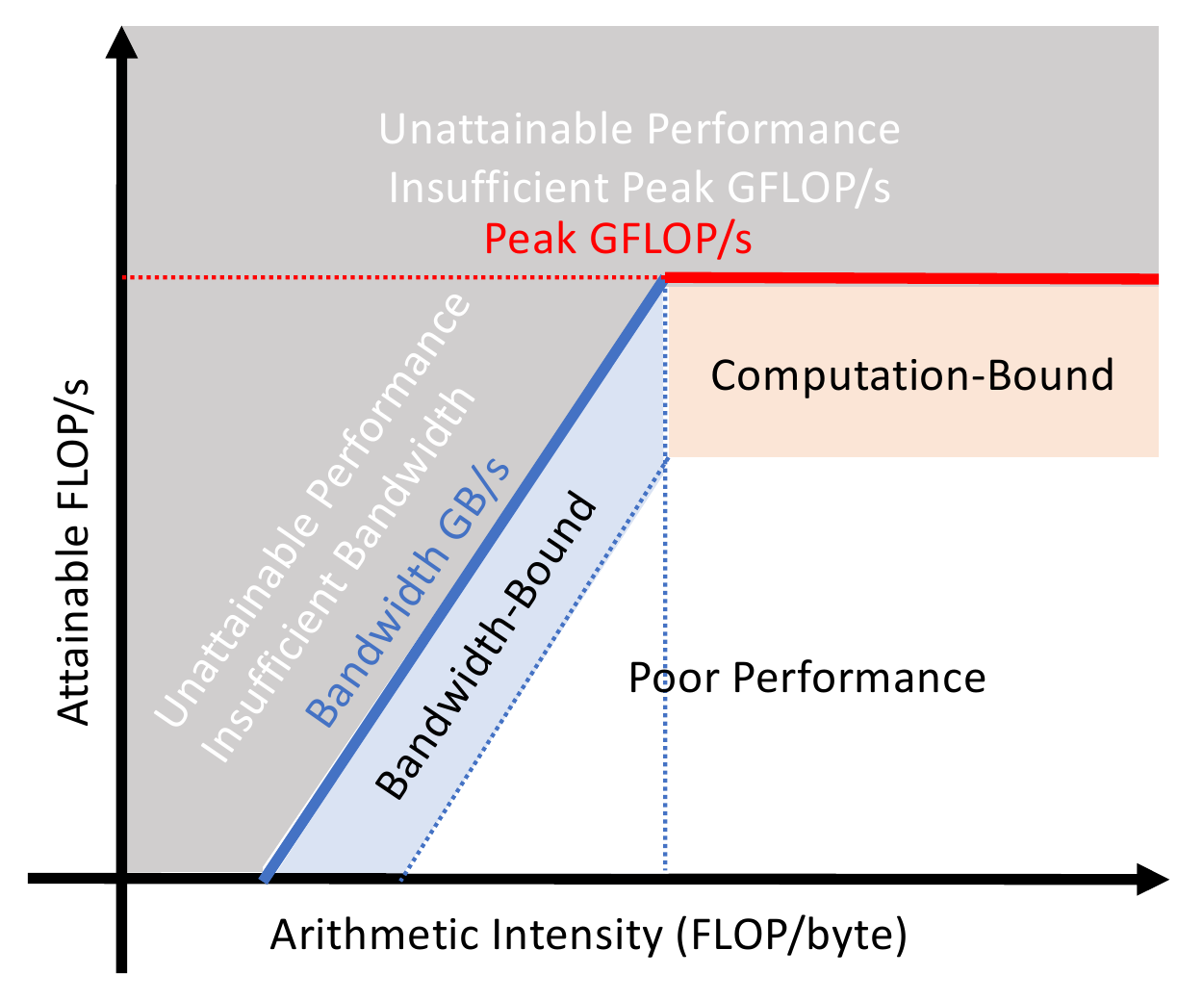
Figure 1. Roofline model.
The lower limit determines the roof. On the sloped part, memory bandwidth limits the possible rate; on the flat part, computing capacity sets the limit. Their meeting point, called the ridge point, marks the minimum operations per byte needed to reach peak compute performance [5].

2.3 ResNet Models
ResNet offers models with different numbers of layers within one family [6]. We use these models to study how adding layers changes the amount of computation and GPU performance.
ResNet was designed to make deep networks easier to train. Its shortcut connections add a block’s input to the output of its layers, an approach called residual learning. He et al. [6] write this as y = F(x, {Wᵢ}) + x, where x and y are the input and output, and F represents the block’s calculation using weights {Wᵢ}. Their experiments show that these connections make deeper networks easier to train [6].
ResNet models differ in their numbers of layers and the blocks they use. ResNet-18 and ResNet-34 use basic blocks with two main convolutional layers. ResNet-50, ResNet-101, and ResNet-152 use bottleneck blocks with three main convolutional layers. The model names give the conventional count of layers with learned weights [6].
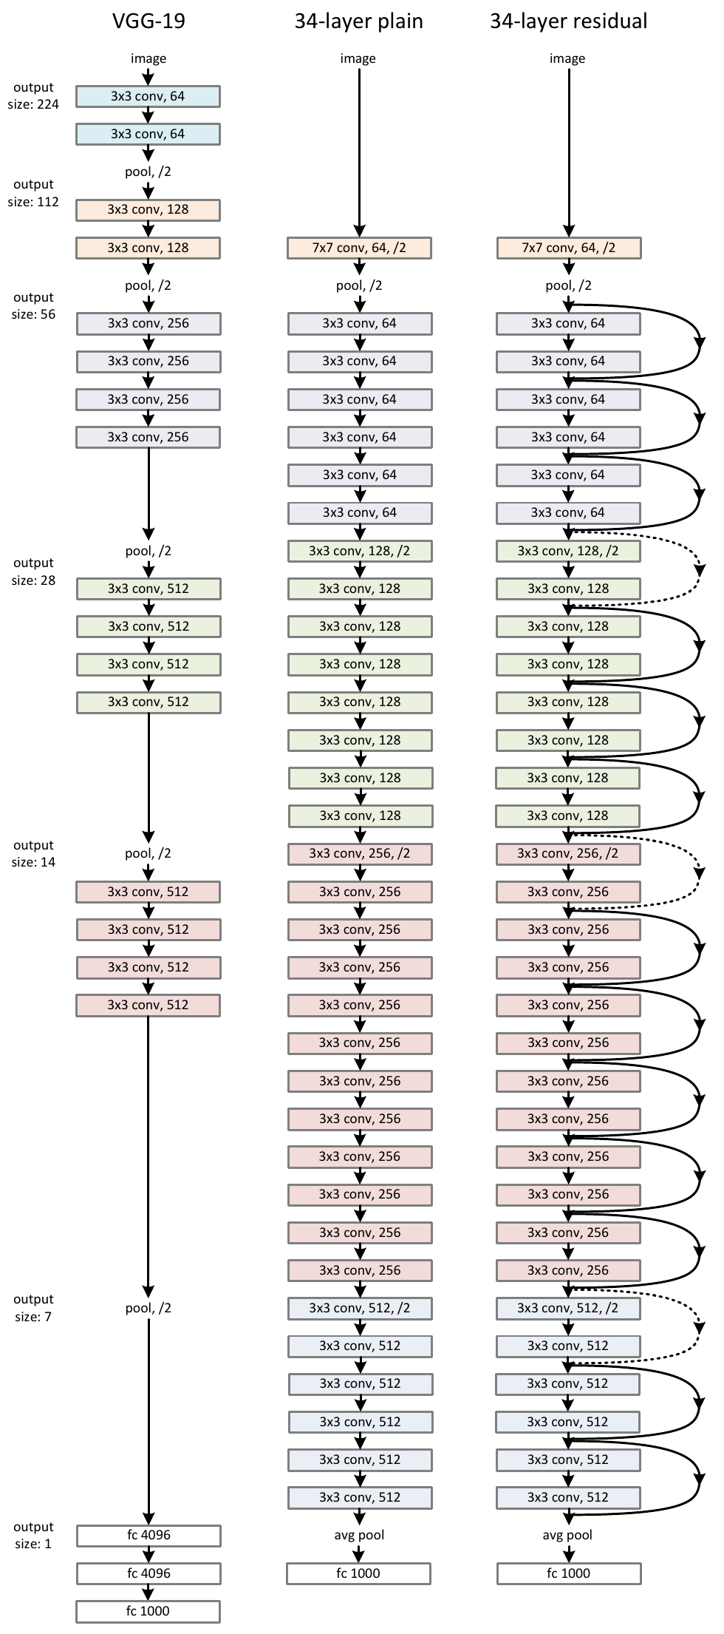
Figure 2. ImageNet network architectures.

Methodology
Component | Configuration | Purpose
Environment | NVIDIA L4 and A100 40 GB | Compare how different GPUs perform on the same workload.
Model | ResNet-50, ResNet-101, and ResNet-152 | Study how network depth affects performance within one model family.
Batch size | 32 | Keep the number of images per training step fixed across comparisons.
Data | A small, fixed ImageNet subset | Use the same images and preprocessing across all experiments.
Precision | FP32 (32-bit floating point) | Use the same numerical precision in every experiment.

3.1 Experimental Design and Setup
We compare ResNet-50, ResNet-101, and ResNet-152 on NVIDIA L4 and A100 40 GB GPUs. These six combinations show how training performance changes with GPU type and the number of model layers.
1. Load the three ResNet models in PyTorch and Torchvision and prepare the ImageNet subset.
2. Estimate the forward calculations for each model using the method in Section 3.2.
3. After warm-up, measure training-step time, images processed per second, and peak GPU memory use for each model on each GPU.
4. Use NVIDIA Nsight Compute in separate runs to measure arithmetic operations, GPU memory transfers, and the time of individual GPU programs (kernels) during the forward and backward passes.
5. Draw forward and backward Roofline plots for each GPU and compare the results across GPUs and model depths.

3.2 Workload Complexity
The image below reproduces the original ResNet architecture table for all five models [6]. It shows layer sizes, convolutional blocks, and the number of times each block is repeated for a 224 × 224 RGB image.
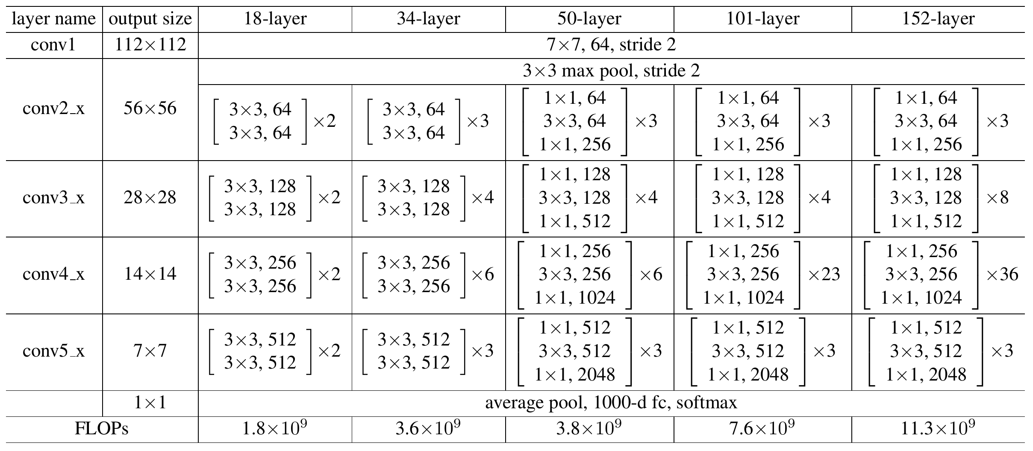
Table 1. ResNet architectures [6, Table 1].
The calculations use Torchvision’s ResNet V1.5, batch size 32, FP32, and training of all layers. In the first block of conv3_x, conv4_x, and conv5_x, a stride of 2 in the 3 × 3 convolution reduces the image dimensions. The original paper puts this stride in the first 1 × 1 convolution. Its FLOP row is shown as published; our calculations use the V1.5 stride placement and count two FLOPs per multiply-add.

Forward FLOPs per layer
$${FLOPs}_{conv} = 2K_{h}K_{w}C_{in}C_{out}H_{out}W_{out}$$
FLOPs_{conv} counts forward operations for one convolution and one image; K_{h} and K_{w} are kernel height and width; C_{in} and C_{out} are input and output channels; H_{out} and W_{out} are output height and width. Each output value requires K_{h} × K_{w} × C_{in} multiply-adds. Multiplying by the number of output values and counting two FLOPs per multiply-add gives the layer total. These convolutions have one group.
$${FLOPs}_{fc} = 2D_{in}D_{out}$$
FLOPs_{fc} counts the classifier’s forward operations for one image; D_{in} and D_{out} are its input and output sizes (2,048 and 1,000). Each output combines all inputs, giving D_{in} × D_{out} multiply-adds.

Total forward FLOPs per image
$$FLOPs = \sum_{j}{r_{j}{FLOPs}_{j}}$$
FLOPs is the total forward operation count per image; j identifies a layer or group of blocks; r_{j} is its repetition count; FLOPs_{j} counts forward operations for one layer or block in that group. Add the convolutions in each block, including any projection shortcut. Multiply by the number of repetitions, then add the group totals to get the model total.

Batch forward FLOPs
$${FLOPs}_{batch} = B × FLOPs$$
FLOPs_{batch} counts forward operations per batch; B is batch size (32); FLOPs counts forward operations per image. Multiply the per-image count by B to get the batch total.
The tables summarize the accompanying Excel workbook. Each block’s FLOP total includes its three convolutions and any projection shortcut. Input and output sizes are shown as channels (C), height (H), and width (W) for one image; the classifier uses C × 1 × 1. GFLOPs and TFLOPs mean billions and trillions of operations. Each row covers one block or the stated range of repeated blocks. Row totals include all repetitions and are calculated before rounding.

ResNet-50 calculations
Layer / block | Count | Input |  |  | Output |  |  | Forward GFLOPs  per image
Layer / block | Count | C | H | W | C | H | W | Forward GFLOPs  per image
conv1 | 1 | 3 | 224 | 224 | 64 | 112 | 112 | 0.236
Max pool | 1 | 64 | 112 | 112 | 64 | 56 | 56 | Not counted
conv2_1 | 1 | 64 | 56 | 56 | 256 | 56 | 56 | 0.462
conv2_2–3 | 2 | 256 | 56 | 56 | 256 | 56 | 56 | 0.873
conv3_1 | 1 | 256 | 56 | 56 | 512 | 28 | 28 | 0.745
conv3_2–4 | 3 | 512 | 28 | 28 | 512 | 28 | 28 | 1.310
conv4_1 | 1 | 512 | 28 | 28 | 1,024 | 14 | 14 | 0.745
conv4_2–6 | 5 | 1,024 | 14 | 14 | 1,024 | 14 | 14 | 2.184
conv5_1 | 1 | 1,024 | 14 | 14 | 2,048 | 7 | 7 | 0.745
conv5_2–3 | 2 | 2,048 | 7 | 7 | 2,048 | 7 | 7 | 0.873
Average pool | 1 | 2,048 | 7 | 7 | 2,048 | 1 | 1 | Not counted
Classifier | 1 | 2,048 | 1 | 1 | 1,000 | 1 | 1 | 0.004
Model total | — | — | — | — | — | — | — | 8.178

ResNet-101 calculations
Layer / block | Count | Input |  |  | Output |  |  | Forward GFLOPs  per image
Layer / block | Count | C | H | W | C | H | W | Forward GFLOPs  per image
conv1 | 1 | 3 | 224 | 224 | 64 | 112 | 112 | 0.236
Max pool | 1 | 64 | 112 | 112 | 64 | 56 | 56 | Not counted
conv2_1 | 1 | 64 | 56 | 56 | 256 | 56 | 56 | 0.462
conv2_2–3 | 2 | 256 | 56 | 56 | 256 | 56 | 56 | 0.873
conv3_1 | 1 | 256 | 56 | 56 | 512 | 28 | 28 | 0.745
conv3_2–4 | 3 | 512 | 28 | 28 | 512 | 28 | 28 | 1.310
conv4_1 | 1 | 512 | 28 | 28 | 1,024 | 14 | 14 | 0.745
conv4_2–23 | 22 | 1,024 | 14 | 14 | 1,024 | 14 | 14 | 9.608
conv5_1 | 1 | 1,024 | 14 | 14 | 2,048 | 7 | 7 | 0.745
conv5_2–3 | 2 | 2,048 | 7 | 7 | 2,048 | 7 | 7 | 0.873
Average pool | 1 | 2,048 | 7 | 7 | 2,048 | 1 | 1 | Not counted
Classifier | 1 | 2,048 | 1 | 1 | 1,000 | 1 | 1 | 0.004
Model total | — | — | — | — | — | — | — | 15.603

ResNet-152 calculations
Layer / block | Count | Input |  |  | Output |  |  | Forward GFLOPs  per image
Layer / block | Count | C | H | W | C | H | W | Forward GFLOPs  per image
conv1 | 1 | 3 | 224 | 224 | 64 | 112 | 112 | 0.236
Max pool | 1 | 64 | 112 | 112 | 64 | 56 | 56 | Not counted
conv2_1 | 1 | 64 | 56 | 56 | 256 | 56 | 56 | 0.462
conv2_2–3 | 2 | 256 | 56 | 56 | 256 | 56 | 56 | 0.873
conv3_1 | 1 | 256 | 56 | 56 | 512 | 28 | 28 | 0.745
conv3_2–8 | 7 | 512 | 28 | 28 | 512 | 28 | 28 | 3.057
conv4_1 | 1 | 512 | 28 | 28 | 1,024 | 14 | 14 | 0.745
conv4_2–36 | 35 | 1,024 | 14 | 14 | 1,024 | 14 | 14 | 15.286
conv5_1 | 1 | 1,024 | 14 | 14 | 2,048 | 7 | 7 | 0.745
conv5_2–3 | 2 | 2,048 | 7 | 7 | 2,048 | 7 | 7 | 0.873
Average pool | 1 | 2,048 | 7 | 7 | 2,048 | 1 | 1 | Not counted
Classifier | 1 | 2,048 | 1 | 1 | 1,000 | 1 | 1 | 0.004
Model total | — | — | — | — | — | — | — | 23.027

Batch FLOP estimates
Model | Forward GFLOPs  per batch of 32
ResNet-50 | 261.708
ResNet-101 | 499.290
ResNet-152 | 736.872
These estimates count forward convolution and classifier operations. They exclude normalization, activations, pooling, residual and bias additions, loss, and optimizer updates. The forward and backward counts used in the Roofline plots are measured separately in Section 3.3.

3.3 Measurement Procedure
The forward pass calculates model outputs, and the backward pass calculates gradients. Updating the model’s weights is timed as part of the full training step but is excluded from the Roofline plots.
1. Run warm-up steps for each model on each GPU so initialization and kernel selection finish before timing.
2. Use CUDA events to time gradient reset, the forward pass, loss calculation, the backward pass, and the optimizer update. Wait for GPU work to finish before reading the time.
3. Restore the model and optimizer to the same starting states before each repetition. Report step time, images per second, and peak allocated GPU memory for each repetition.
4. After warm-up, use NVIDIA Nsight Compute to measure the forward and backward passes separately. Collect operations, memory transfers, and execution time for the same kernel calls.
For the measures below, n is the number of timed steps and T is their total time in seconds, measured with CUDA events; batch size is 32. Save profiling results separately for each model, GPU, and pass.
Metric | Unit | Calculation or measurement
Mean step time | ms / step | 1,000 × T/n, using CUDA-event intervals.
Image throughput | images / s | 32n/T, using the same timed GPU interval.
GPU speedup | ratio | Average L4 step time / average A100 step time for the same model.
Peak allocated memory | MiB | After warm-up and before timing, reset the peak-memory counter. Read max_memory_allocated() and convert to MiB.
Measured operations | FLOPs | Nsight Compute counts of floating-point additions and multiplications.
GPU memory transfers | bytes | Nsight Compute DRAM bytes read plus bytes written.
Kernel duration | µs | Nsight Compute time for the same kernel call used to count operations and memory transfers.

3.4 Roofline Construction
1. Draw a roof for each GPU using its peak FP32 calculation rate and memory bandwidth. The sloped line is bandwidth × arithmetic intensity; the flat line is the peak compute rate [5].
2. For each model and pass, add the measured FLOPs, GPU memory bytes read and written, and execution times across its kernels. Use the same kernel calls for all three totals.
3. Divide total FLOPs by total transferred bytes to get arithmetic intensity (FLOP/byte). Divide total FLOPs by the summed kernel time in seconds to get the measured calculation rate (FLOP/s) [11].
4. Plot the forward and backward results in separate panels for each GPU. Use the same roof and axis scales, show rates in GFLOP/s, and label each ResNet model [11].
5. To see what each combined point contains, group the same kernels by name into convolution and matrix-multiplication kernels (including cuDNN helper kernels) and batch-normalization and element-wise kernels (ReLU, residual addition, and their gradients). Compute the same totals for each group, and plot every kernel on one Roofline per GPU (Figure 5).

Results and Analysis
These results compare training time, image throughput, and memory use. The Roofline plots relate measured calculation rates to GPU memory transfers.

4.1 Training Performance and Memory Use
Table 2. Training measurements (step times averaged over 50 steps).
Model | GPU | Repeat | Average step  time (ms) | Throughput  (images/s) | Peak allocated  memory (MiB)
ResNet-50 | L4 | 1 | 167.991 | 190.49 | 2,938.93
ResNet-50 | L4 | 2 | 168.677 | 189.71 | 2,940.75
ResNet-50 | L4 | 3 | 169.598 | 188.68 | 2,940.75
ResNet-50 | A100 | 1 | 71.974 | 444.60 | 2,967.56
ResNet-50 | A100 | 2 | 72.000 | 444.45 | 2,970.68
ResNet-50 | A100 | 3 | 71.957 | 444.71 | 2,970.68
ResNet-101 | L4 | 1 | 267.856 | 119.47 | 4,332.19
ResNet-101 | L4 | 2 | 269.278 | 118.84 | 4,331.69
ResNet-101 | L4 | 3 | 271.504 | 117.86 | 4,331.69
ResNet-101 | A100 | 1 | 118.268 | 270.57 | 4,354.69
ResNet-101 | A100 | 2 | 118.272 | 270.56 | 4,358.94
ResNet-101 | A100 | 3 | 118.305 | 270.49 | 4,358.94
ResNet-152 | L4 | 1 | 388.877 | 82.29 | 6,001.67
ResNet-152 | L4 | 2 | 394.398 | 81.14 | 6,005.42
ResNet-152 | L4 | 3 | 392.327 | 81.56 | 6,005.42
ResNet-152 | A100 | 1 | 165.758 | 193.05 | 6,021.05
ResNet-152 | A100 | 2 | 165.722 | 193.09 | 6,024.92
ResNet-152 | A100 | 3 | 165.717 | 193.10 | 6,024.92
A100 completes training steps faster than L4 for all three models, while deeper models take more time and use more memory on both GPUs.

4.2 Forward and Backward Roofline Analysis
Table 3 lists the hardware limits used to draw each GPU’s Roofline.
Table 3. GPU specifications.
GPU | Peak FP32  (GFLOP/s) | DRAM bandwidth  (GB/s) | Ridge point  (FLOP/byte)
L4 [12] | 30,300 | 300 | 101.00
A100 SXM4 40 GB [13] | 19,500 | 1,555 | 12.54
Each point combines the measurements from one model’s forward or backward kernels.
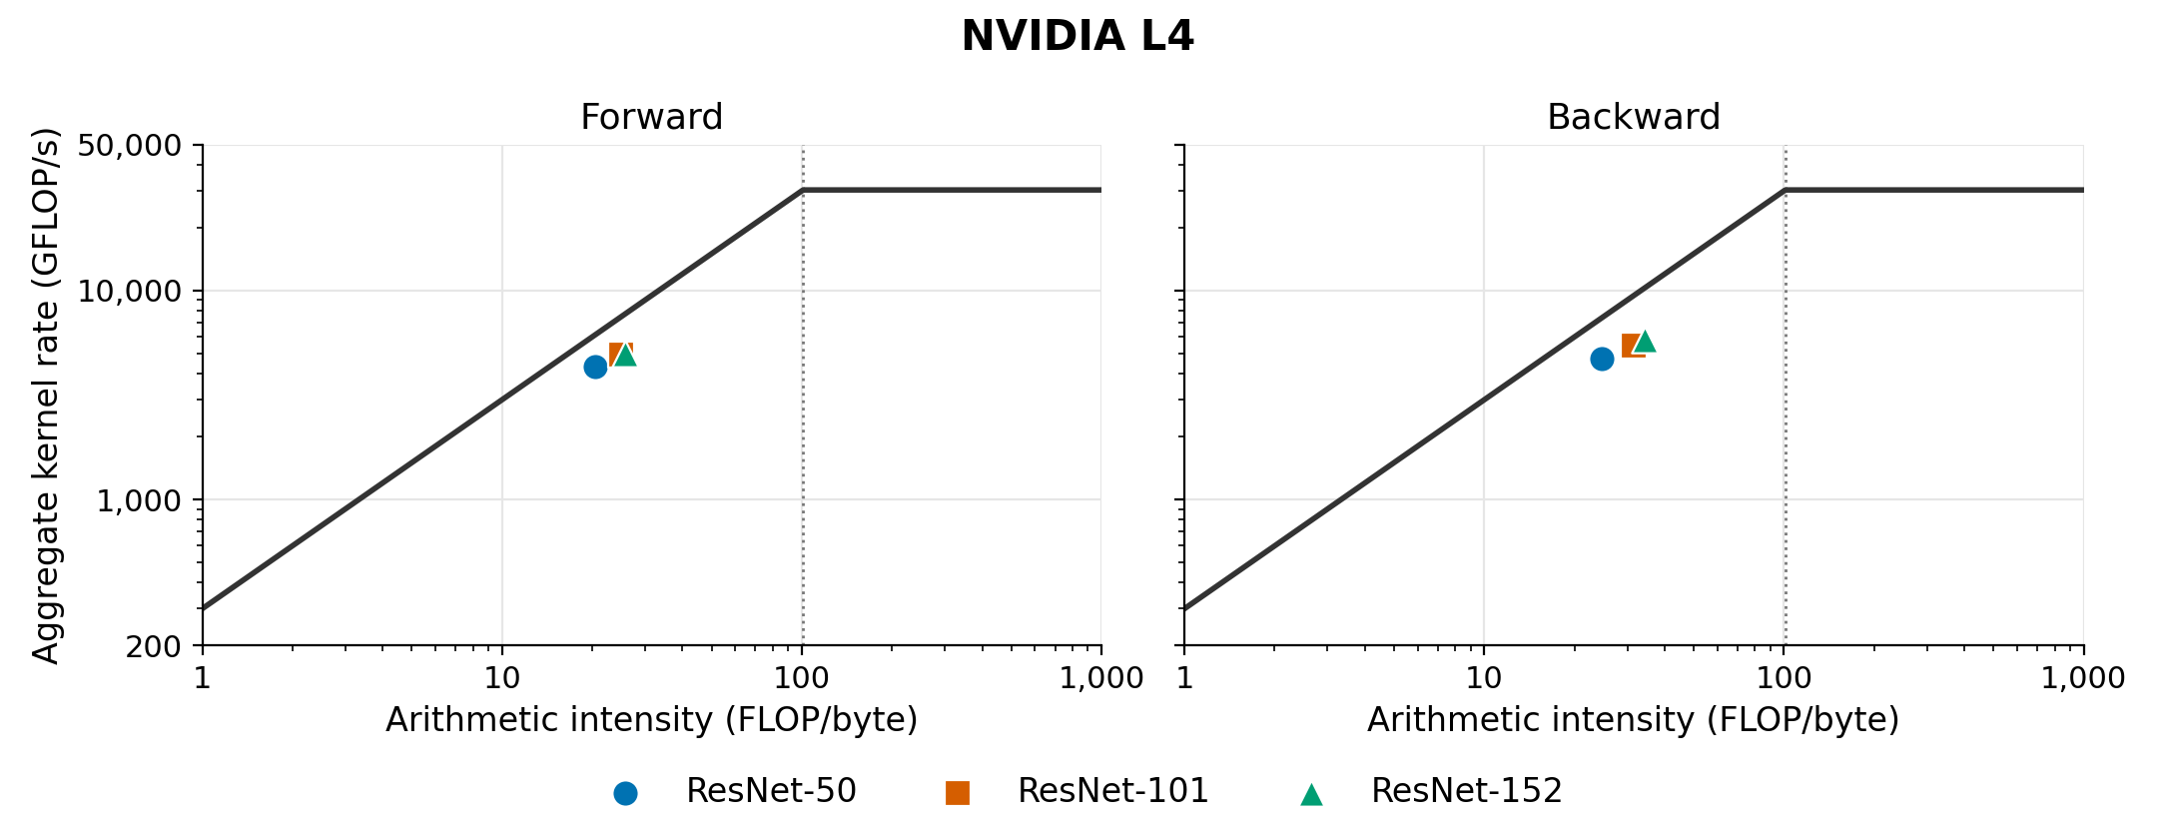
Figure 3. L4 Roofline analysis.
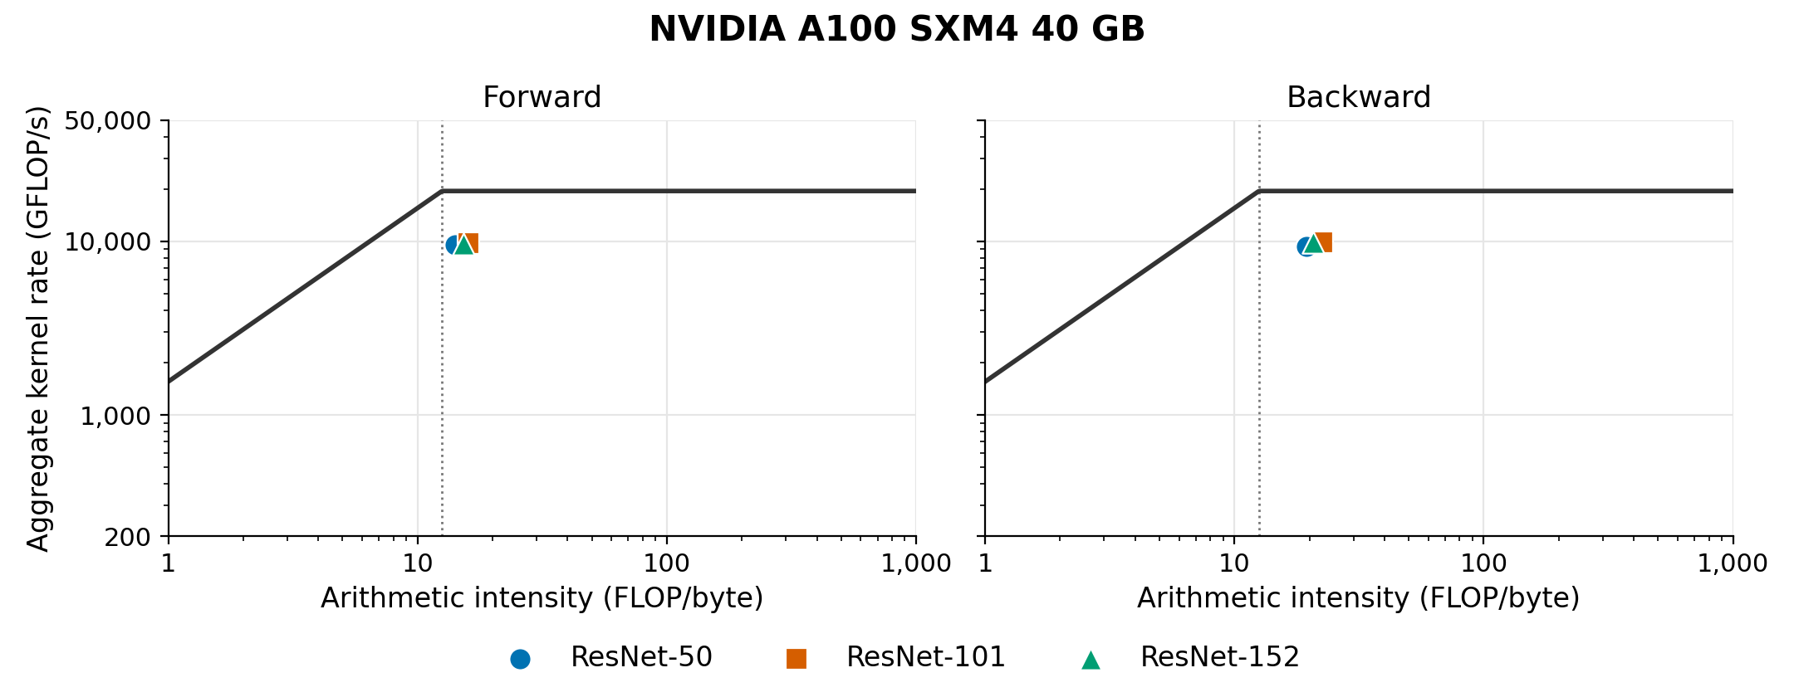
Figure 4. A100 Roofline analysis.
Table 4. Roofline results.
GPU | Model | Phase | Intensity  (FLOP/byte) | Rate  (GFLOP/s) | Roof  fraction*
L4 | ResNet-50 | Forward | 20.47 | 4,346 | 70.8%
L4 | ResNet-50 | Backward | 24.62 | 4,742 | 64.2%
L4 | ResNet-101 | Forward | 25.02 | 4,955 | 66.0%
L4 | ResNet-101 | Backward | 31.64 | 5,438 | 57.3%
L4 | ResNet-152 | Forward | 25.72 | 5,009 | 64.9%
L4 | ResNet-152 | Backward | 34.35 | 5,815 | 56.4%
A100 | ResNet-50 | Forward | 14.14 | 9,520 | 48.8%
A100 | ResNet-50 | Backward | 19.40 | 9,377 | 48.1%
A100 | ResNet-101 | Forward | 15.98 | 9,800 | 50.3%
A100 | ResNet-101 | Backward | 22.57 | 9,865 | 50.6%
A100 | ResNet-152 | Forward | 15.30 | 9,676 | 49.6%
A100 | ResNet-152 | Backward | 20.66 | 9,892 | 50.7%
* Roof fraction is the measured calculation rate divided by the Roofline limit at that intensity.
The chart suggests that the workload is memory-bandwidth-bound on L4. Deeper models perform more calculations per byte and per second, but reach a smaller share of the limit set by memory bandwidth. ResNet-50 comes closest to that limit in both passes. To improve performance, one could consider reducing data transfer between GPU memory and the compute units.
On A100, the points sit near the ridge. This suggests a closer match between the workload and the GPU’s balance of memory bandwidth and computing capacity. The points are close together, so changing model depth makes little difference to the achieved calculation rate.
Each point, however, combines hundreds of kernels with different behavior, so its position does not show which limit applies to the kernels that take most of the time. Section 4.3 separates them.

4.3 Kernel-Level Analysis
Table 5 and Figure 5 split the profiled kernels into the two groups defined in Section 3.4.
Table 5. Kernel time by kernel group (forward and backward passes combined).
GPU | Model | Conv/GEMM  share of time | Conv/GEMM rate,  GFLOP/s (% of peak) | BN + element-wise  share of time | BN + element-wise  DRAM GB/s (% of peak)
L4 | ResNet-50 | 56.1% | 8,115 (27%) | 42.8% | 277 (92%)
L4 | ResNet-101 | 62.1% | 8,431 (28%) | 37.2% | 278 (93%)
L4 | ResNet-152 | 63.1% | 8,737 (29%) | 36.4% | 277 (92%)
A100 | ResNet-50 | 71.7% | 12,959 (66%) | 27.2% | 1,105 (71%)
A100 | ResNet-101 | 75.8% | 12,847 (66%) | 23.5% | 1,114 (72%)
A100 | ResNet-152 | 75.5% | 12,871 (66%) | 24.0% | 1,133 (73%)
The two groups hit different limits. Batch normalization and element-wise kernels do little arithmetic but take a large share of time, and on L4 they run close to peak memory bandwidth. L4 convolutions, by contrast, reach neither roof: even the fastest L4 kernel stays below half of the published FP32 peak, while A100 convolutions come close to theirs (Figure 5). L4’s published peak therefore overstates what these FP32 kernels achieve.
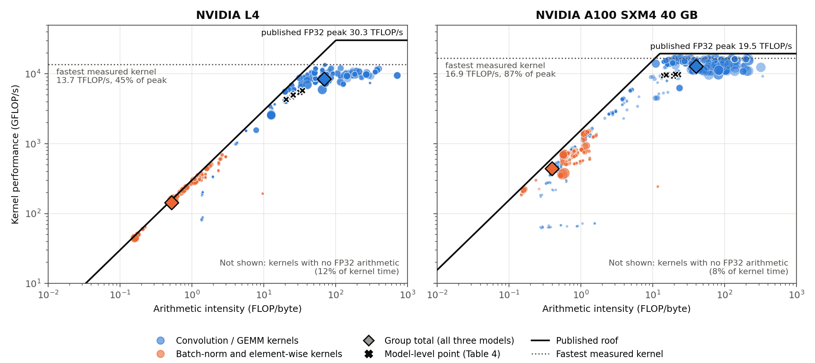
Figure 5. Kernel-level Roofline for all three models, forward and backward passes.
Table 6. A100 speedup over L4 by kernel group.
Model | Training  step | All profiled  kernels | Conv/GEMM  kernels | BN + element-  wise kernels | BN + element-wise share  of L4’s extra kernel time
ResNet-50 | 2.34× | 2.21× | 1.73× | 3.48× | 56%
ResNet-101 | 2.28× | 2.07× | 1.70× | 3.28× | 50%
ResNet-152 | 2.36× | 2.06× | 1.72× | 3.13× | 48%
Training-step speedup uses the mean step times in Table 2. Kernel speedups use summed profiled kernel time.
A100’s lead is about twice as large on batch normalization and element-wise kernels as on convolutions (Table 6), and these memory-bound kernels account for about half of L4’s extra time. Reducing their memory traffic, through kernel fusion or 16-bit data, would help L4 most.

4.4 Model Complexity Discussions
Table 7 brings our estimates and measurements together.
Table 7. Forward operation counts.
Model | Estimated  GFLOPs | L4 measured  GFLOPs | A100 measured  GFLOPs
ResNet-50 | 261.708 | 212.925 | 208.825
ResNet-101 | 499.290 | 376.904 | 364.687
ResNet-152 | 736.872 | 535.064 | 519.846
The measured counts are lower than our estimates because the profiler counts the arithmetic the GPU actually performs. The GPU’s math library often computes convolutions with shortcut methods that reach the same result with fewer operations, and it chooses these methods separately on each GPU. The two GPUs therefore do slightly different amounts of arithmetic for the same training step, so images processed per second is the fairest way to compare them.
A100 performed better than L4 throughout this analysis. Roofline results, however, are specific to both the hardware and the application, so a different application could show the opposite result.
Adding layers does not substantially improve the achieved calculation rate on A100, although step time grows more slowly than the analytical operation count. For a task where training-step speed and memory use are the priorities, ResNet-50 is still favored over the deeper models in our comparison.

Conclusion and Future Work
A100 trained all three ResNet models more than twice as fast as L4, even though L4 has the higher compute roof (published FP32 peak) in the Roofline model. The model-level Roofline explains part of this: on L4, every model falls on the memory-bandwidth side of the roof, where A100’s much higher bandwidth gives it the advantage. The kernel-level analysis then shows more detail. Batch normalization and element-wise kernels are limited by memory bandwidth and cause about half of L4’s extra time, while L4’s convolutions stay far below its compute roof, so its published peak overstates what it achieves on this workload.
Limitations. Because of GPU availability, L4 ran on a personal Google Cloud VM and A100 on NYU HPC through Open OnDemand, so host CPU, driver, and profiler versions also differed.
Future work could train with 16-bit numbers (mixed precision), which cuts memory traffic and is how these GPUs are usually used, and test a wider variety of models to understand which types of workloads suit each GPU.

References
[1] Bianco et al. Benchmark Analysis of Representative Deep Neural Network Architectures. IEEE Access, 2018.
[2] Mattson et al. MLPerf Training Benchmark. MLSys, 2020.
[3] Coleman et al. Analysis of DAWNBench, a Time-to-Accuracy Machine Learning Performance Benchmark. ACM SIGOPS Operating Systems Review, 2019.
[4] Micikevicius et al. Mixed Precision Training. ICLR, 2018.
[5] Williams et al. Roofline: An Insightful Visual Performance Model for Multicore Architectures. Communications of the ACM, 2009.
[6] He et al. Deep Residual Learning for Image Recognition. CVPR, 2016.
[7] Simonyan and Zisserman. Very Deep Convolutional Networks for Large-Scale Image Recognition. ICLR, 2015.
[8] Sandler et al. MobileNetV2: Inverted Residuals and Linear Bottlenecks. CVPR, 2018.
[9] Tan and Le. EfficientNet: Rethinking Model Scaling for Convolutional Neural Networks. ICML, 2019.
[10] Liu et al. A ConvNet for the 2020s. CVPR, 2022.
[11] Yang et al. Hierarchical Roofline Performance Analysis for Deep Learning Applications. Intelligent Computing, 2021.
[12] NVIDIA. NVIDIA L4 Tensor Core GPU. Product specifications. https://www.nvidia.com/en-us/data-center/l4/.
[13] Krashinsky et al. NVIDIA Ampere Architecture In-Depth. NVIDIA Technical Blog, May 14, 2020. https://developer.nvidia.com/blog/nvidia-ampere-architecture-in-depth/.
AI assistance: I used OpenAI Codex (Astra 6) to help me understand the requirements. I wrote an initial plan, and Codex helped refine it and assisted with the implementation. I used Claude (Opus 5.5) to assist with debugging and provide critiques. I reviewed the training results and drafted and revised the report, with Codex assisting with selected sections and tables. I made the final design decisions and take responsibility for the final analysis.
Project files: GitHub repository

